5.4.2 Conic Sections (Ellipses)

If a plane passes through a double right circular cone there are four possible resulting curves. These curves are the parabola, circle, ellipse, and hyperbola. These curves are called conic sections and are shown below.
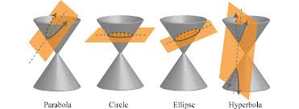

Definition: An ellipse is the set of all points in a plane such that the sum of their distances from two fixed points is constant. Each fixed point is call a focus (plural foci) of the ellipse.

The Equation of an Ellipse: (with a horizontal major axis and center at the origin)
The ellipse with center at the origin and equation

has vertices , endpoints of the minor axis , and foci .
where

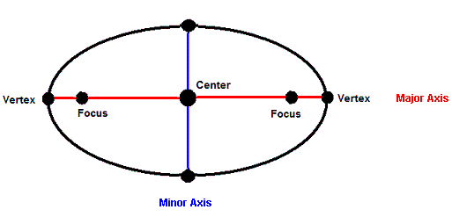
$$(0,0)$$
$$(0,b)$$
$$(0,-b)$$
$$(c,0)$$

$$b$$
$$a$$
$$(a,0)$$
$$(-a,0)$$

Developing the Equation of an Ellipse: (Not done in class)

$$(0,0)$$
$$(0,b)$$
$$(0,-b)$$
$$(c,0)$$
$$(-c,0)$$
$$(x,y)$$
$$a$$
$$a$$
Note here that $b^{2}+c^{2}=a^{2}$

$$b$$
$$c$$

We see that the sum of the distances from to and from to should be equal to 2a.

Since we can see from our figure that we then know that . So we have
Also note that if let then we can find our x-intercepts.
So we have x-intercepts at
The Equation of an Ellipse: (with a vertical major axis and center at the origin)
The ellipse with center at the origin and equation

has vertices , endpoints of the minor axis , and foci .
where

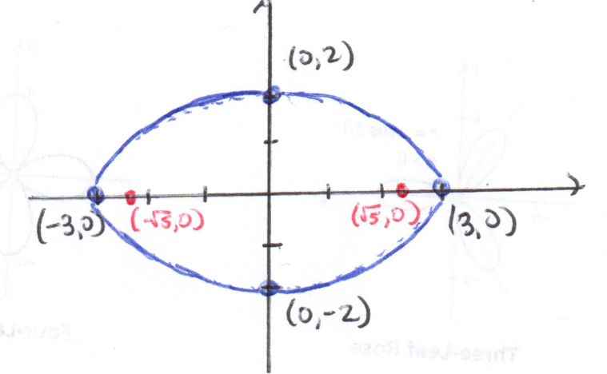
Example 1: Sketch a graph and identify the foci of the ellipse:

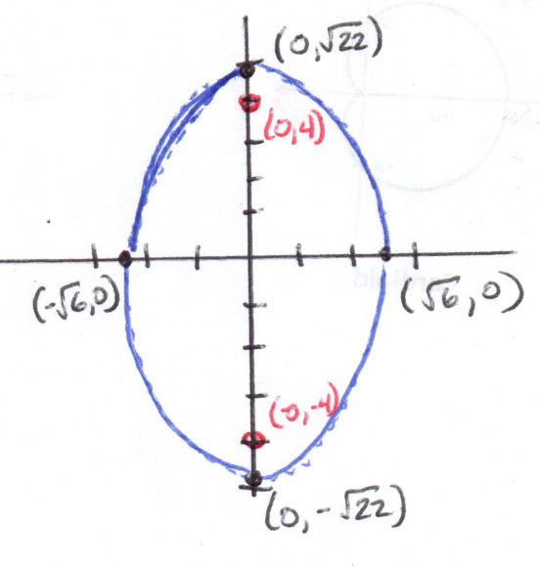
Example 2: Sketch a graph and identify the foci of the ellipse:

We first put this ellipse in standard form.

Example 3: Write the equation of an ellipse with foci and vertices .
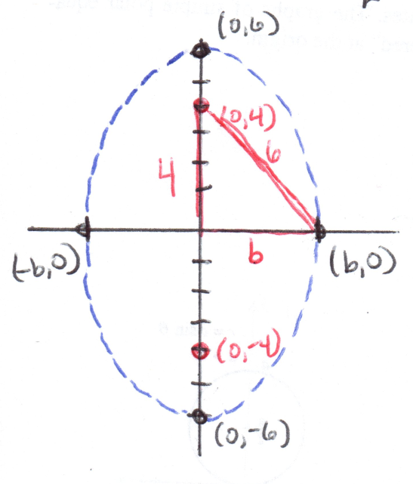
Since our foci are given by the points we see that

Since our vertices are given by the points we see that

We can also see that since our vertices lie on the $y$-axis, our ellipse has a vertical major axis.

Therefore the equation of our ellipse is:

Fact: The equation representing a conic that has been shifted units horizontally and units vertically can be formed by replacing and ’s in the original equation with and replacing any ’s in the original equation with .

Example 4: Sketch a graph and identify the foci of the ellipse:

We must use the method of completing the square to get the ellipse into standard form
The center of the ellipse occurs at the point:
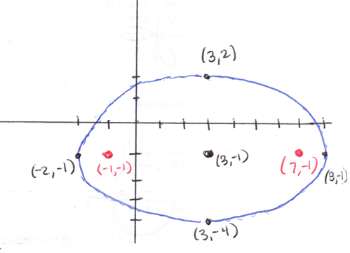

The Circle

Definition: A circle is a set of all points in a plane such that their distance from a point is constant.

Equation for a Circle
The standard equation of a circle with center and radius r is

Note: By dividing both sides of this equation by we obtain . So clearly a circle is an ellipse with major and minor axes of the same length.

Example 5: Write the equation of a circle that has center and passes through the point .
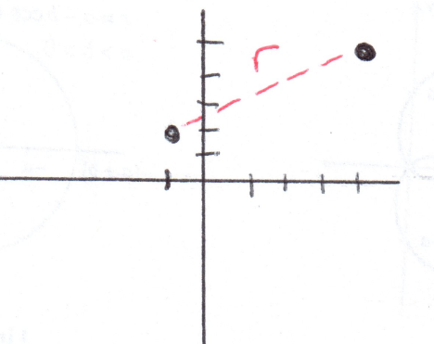
So the equation of the circle is:

Example 6: Determine the center and radius and sketch a graph of the circle given by the equation:

We must use the method of completing the square to get the circle into standard form.

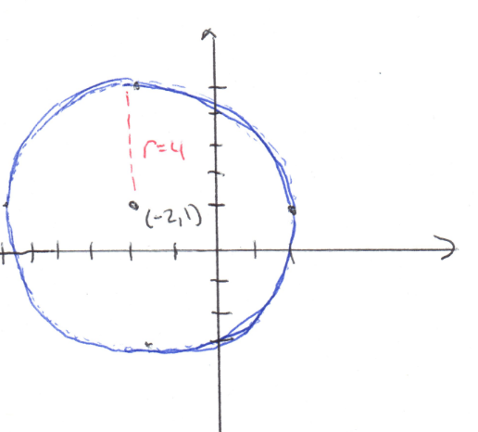

So we have a circle with center and radius .

